***Linked List implementation of Stack***

To implement a [stack](https://www.geeksforgeeks.org/stack-data-structure/) using the singly linked list concept, all the singly [linked list](https://www.geeksforgeeks.org/data-structures/linked-list/) operations should be performed based on Stack operations LIFO(last in first out) and with the help of that knowledge, we are going to implement a stack using a singly linked list.

So we need to follow a simple rule in the implementation of a stack which is **last in first out** and all the operations can be performed with the help of a top variable. Let us learn how to perform **Pop, Push, Peek, and Display** operations in the following article:

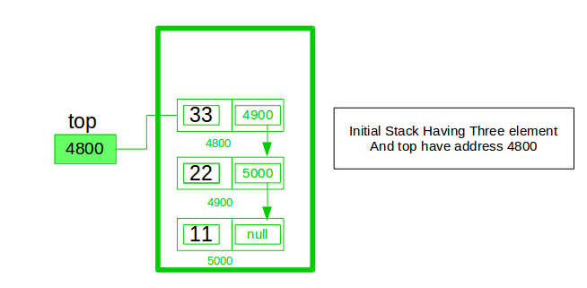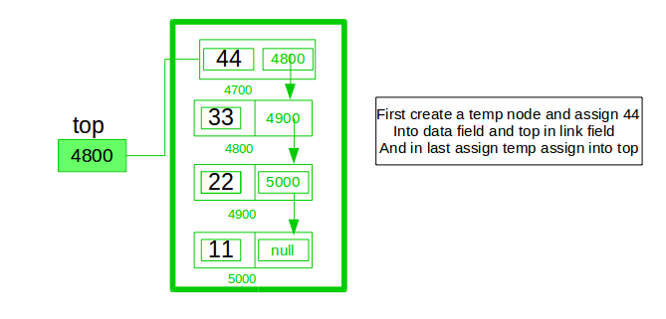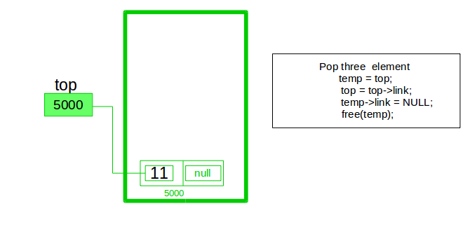

In the stack Implementation, a stack contains a top pointer. which is the “head” of the stack where pushing and popping items happens at the head of the list. The first node has a null in the link field and second node-link has the first node address in the link field and so on and the last node address is in the “top” pointer.

The main advantage of using a linked list over arrays is that it is possible to implement a stack that can shrink or grow as much as needed. Using an array will put a restriction on the maximum capacity of the array which can lead to stack overflow. Here each new node will be dynamically allocated. so overflow is not possible.

**Stack Operations:**

* [**push()**](https://www.geeksforgeeks.org/stack-push-and-pop-in-c-stl/)**:** Insert a new element into the stack i.e just insert a new element at the beginning of the linked list.
* [**pop()**](https://www.geeksforgeeks.org/stack-push-and-pop-in-c-stl/)**:** Return the top element of the Stack i.e simply delete the first element from the linked list.
* [**peek()**](https://www.geeksforgeeks.org/stack-peek-method-in-java/)**:** Return the top element.
* **display():** Print all elements in Stack.

**Push Operation:**

* *Initialise a node*
* *Update the value of that node by data i.e.****node->data = data***
* *Now link this node to the top of the linked list*
* *And update top pointer to the current node*

**Pop Operation:**

* *First Check whether there is any node present in the linked list or not, if not then return*
* *Otherwise make pointer let say****temp****to the top node and move forward the top node by 1 step*
* *Now free this temp node*

**Peek Operation:**

* *Check if there is any node present or not, if not then return.*
* *Otherwise return the value of top node of the linked list*

**Display Operation:**

* *Take a****temp****node and initialize it with top pointer*
* *Now start traversing temp till it encounters NULL*
* *Simultaneously print the value of the temp node*

Below is the implementation of the above operations

C++Java

// Java program to Implement a stack

// using singly linked list

// import package

import static java.lang.System.exit;

// Driver code

class GFG {

public static void main(String[] args)

{

// create Object of Implementing class

StackUsingLinkedlist obj

= new StackUsingLinkedlist();

// insert Stack value

obj.push(11);

obj.push(22);

obj.push(33);

obj.push(44);

// print Stack elements

obj.display();

// print Top element of Stack

System.out.printf("\nTop element is %d\n",

obj.peek());

// Delete top element of Stack

obj.pop();

obj.pop();

// print Stack elements

obj.display();

// print Top element of Stack

System.out.printf("\nTop element is %d\n",

obj.peek());

}

}

// Create Stack Using Linked list

class StackUsingLinkedlist {

// A linked list node

private class Node {

int data; // integer data

Node link; // reference variable Node type

}

// create global top reference variable global

Node top;

// Constructor

StackUsingLinkedlist() { this.top = null; }

// Utility function to add an element x in the stack

public void push(int x) // insert at the beginning

{

// create new node temp and allocate memory

Node temp = new Node();

// check if stack (heap) is full. Then inserting an

// element would lead to stack overflow

if (temp == null) {

System.out.print("\nHeap Overflow");

return;

}

// initialize data into temp data field

temp.data = x;

// put top reference into temp link

temp.link = top;

// update top reference

top = temp;

}

// Utility function to check if the stack is empty or

// not

public boolean isEmpty() { return top == null; }

// Utility function to return top element in a stack

public int peek()

{

// check for empty stack

if (!isEmpty()) {

return top.data;

}

else {

System.out.println("Stack is empty");

return -1;

}

}

// Utility function to pop top element from the stack

public void pop() // remove at the beginning

{

// check for stack underflow

if (top == null) {

System.out.print("\nStack Underflow");

return;

}

// update the top pointer to point to the next node

top = (top).link;

}

public void display()

{

// check for stack underflow

if (top == null) {

System.out.printf("\nStack Underflow");

exit(1);

}

else {

Node temp = top;

while (temp != null) {

// print node data

System.out.print(temp.data);

// assign temp link to temp

temp = temp.link;

if(temp != null)

System.out.print(" -> ");

}

}

}

}

**Output**

44 -> 33 -> 22 -> 11

Top element is 44

22 -> 11

Top element is 22

**Time Complexity:** O(1), for all push(), pop(), and peek(), as we are not performing any kind of traversal over the list. We perform all the operations through the current pointer only.  
**Auxiliary Space:** O(N), where N is the size of the stack